**Upgrade hadoop 1.2.0 to hadoop 2.6.0**

Step 1: You must have 1.2.0 running cluster.



Step 2: Upgrade java8  
  
 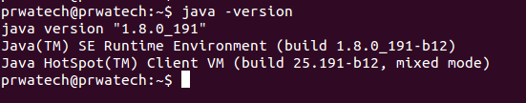

Step 3: Check any upgrade is going on or not.

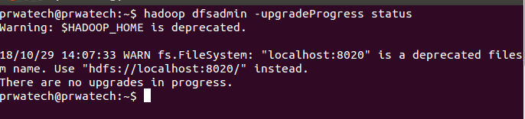

Step 4: Make backup for all data,file of HDFS. using below command.  
  
  
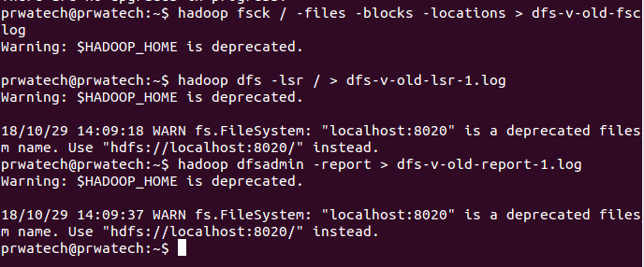  
  
Step 5:- Close your Cluster  
  
   
  
Step 6:- Download Hadoop 2.6.0 and untar that  
  
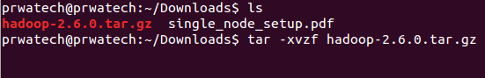  
  
  
Step 7:- Set .bashrc for new hadoop   
  
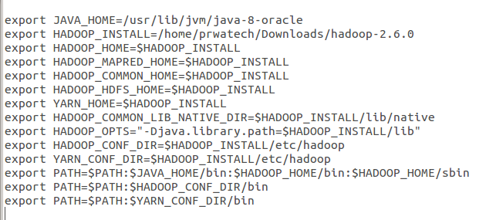  
  
  
Step 8:- Check new version is coming or not  
  
  
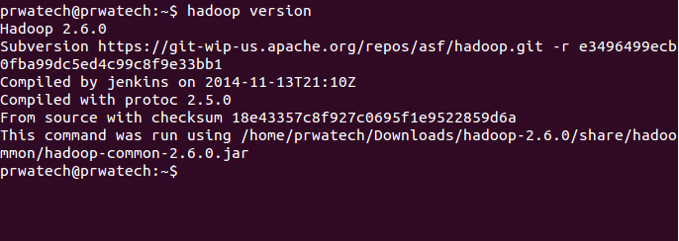  
  
Step 9:- Set all the configuration file.  
  
 core-site.xml  
 hdfs-site.xml  
 mapred-site.xml  
 yarn-site.xml  
 hadoop-env.sh  
  
  
once configure all the above then follow next step  
  
Step 10:- Now upgrade your namenode  
  
  
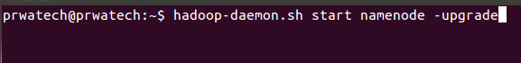  
  
  
Step 11:- Check NameNode started or not  
  
 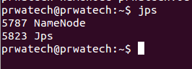  
  
  
Step 12:- Start DataNode  
  
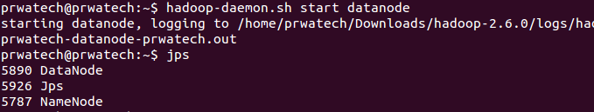  
  
Step 13:- Check all your previous data is there on HDFS or not  
 if data is their then finalize the upgrade otherwise check your configuration and log file   
  
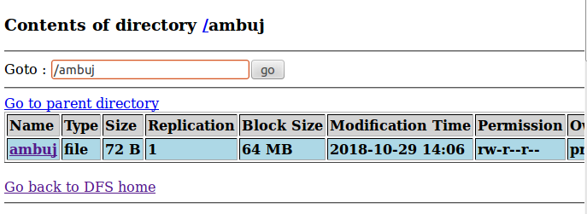  
  
Step 14:- Now finalize your upgrade

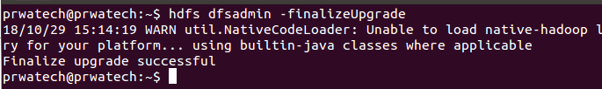

Step 15:- Start other daemons  
  
